**CALLING REPORTS FROM FORMS**

**STEPS**

Startup the report server, this server enables calling of reports from form applications

Edit the following.

C:\DevSuiteHome_1\reports\conf\rwnetwork.conf

<?xml version="1.0" encoding="ISO-8859-1"?>

<!DOCTYPE discoveryService SYSTEM "file:C:\DevSuiteHome_1/reports/dtd/rwnetworkconf.dtd">

<discoveryService>

**<!--multicast channel="228.5.6.7" port="14021" timeout="1000" retry="3"/-->**

**<namingService name="Cos" host="localhost" port="5501"/>**

</discoveryService>

Create a batch file

The batch file contains a list of commands.

Steps

Open notepad and type the following

Start C:\DevSuiteHome_1\bin\namingService 5501

Start C:\DevSuiteHome_1\bin\rwserver server=Cos

Save the file as **reportserver.bat**

**Open oracle forms 10g and create a form**

**Add a report to the form and edit the properties of the form as follows, in the property pallete of the added report.**

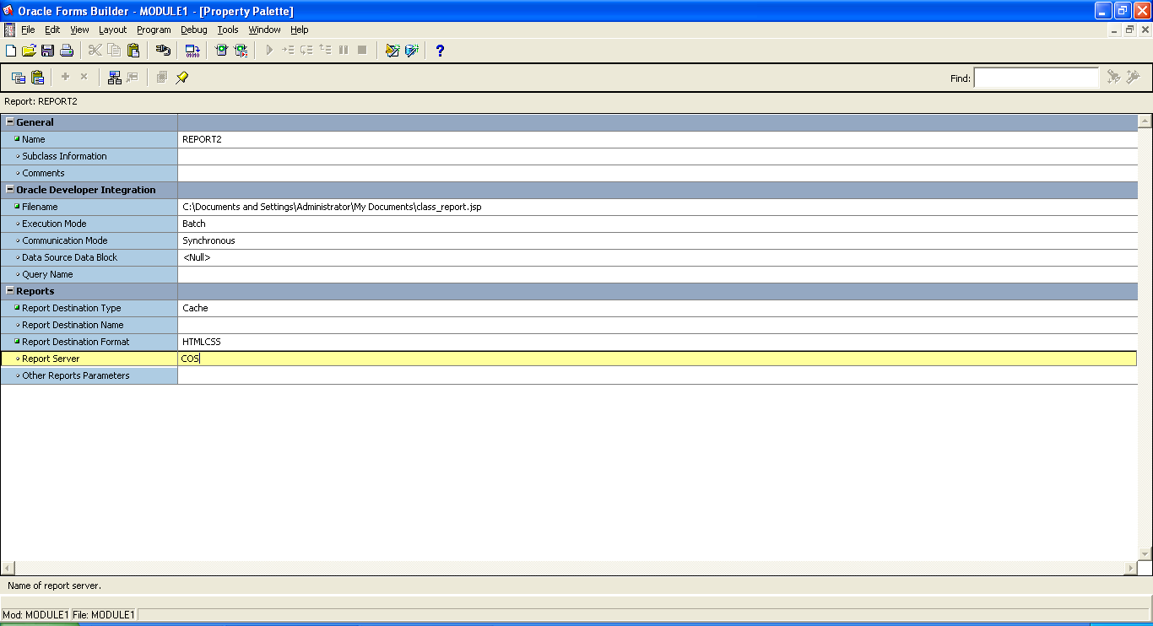

Reports

**Report button**

declare

repid REPORT_OBJECT;

v_rep VARCHAR2(100);

rep_status VARCHAR2(20);

BEGIN

repid:=find_report_object('REPORT39');

v_rep:=RUN_REPORT_OBJECT(repid);

rep_status:=REPORT_OBJECT_STATUS(v_rep);

WHILE rep_status in ('RUNNING','OPENNING_REPORT','ENQUEUED')

LOOP

rep_status:=report_object_status(v_rep);

END LOOP;

IF REP_STATUS='FINISHED' THEN

WEB.SHOW_DOCUMENT('http://localhost:8889/reports/rwservlet/getjobid'

||substr(v_rep,instr(v_rep,'_',-1)+1)||'?'||'server=cos','_blank');

-- begin

--WEB.SHOW_DOCUMENT('http://127.0.0.1:8889/reports/rwservlet?destype=cache$desformat=

htmlcss$report=c:\vista\modules\report_staff.rdf

-- $userid=mose/mose@orcl$paramform=yes');

ELSE

MESSAGE('Error when running report');

end if;

end;

Right click

Start OC4J and run the new Form Application

Click the button to invoke the new report.